**Connecting TELEX to your Teletype via the II Bus**

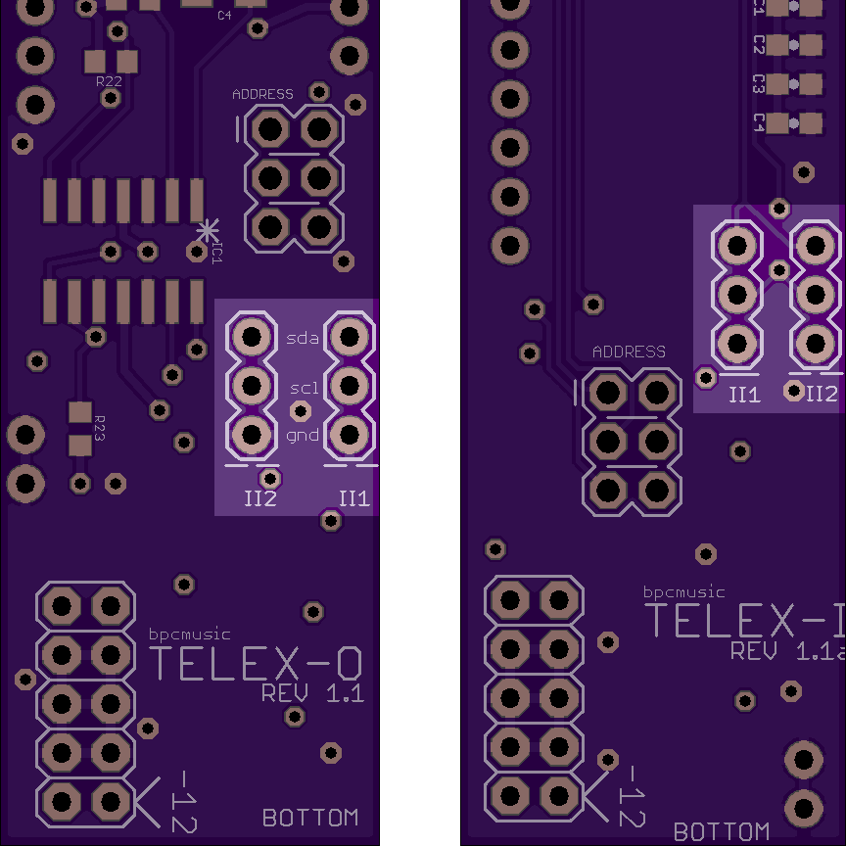The II bus consists of three signals: GND, SCL and SDA. We have included a three-conductor jumper wire with your module to facilitate their connection to the II bus. This is a little different than the ribbon connector and 2x3 connector that is shipped with the Teletype. You can use either one – but there are important considerations you need to keep in mind:

* On the Teletype and Trilogy Modules, the II pins are oriented top to bottom (ground on the top).
* On the TELEX modules and Ansible, these pins are oriented bottom to top (ground on the bottom).
* On the TELEX modules, the vertical columns of II pins are slightly separated (2x3 connectors won’t cover both columns – they are designed for jumpers).

Ensure that you are appropriately orienting your ground wire when connecting the devices together. The rule is “Twist to the Teletype or Trilogy” - if you need a mnemonic.

Each of the TELEX modules has two columns of II pins that are separated slightly. This allows you to use the included jumper cables to daisy-chain from one module to another. The diagrams below illustrate where the pins are located on the two modules. The white lines below the columns on the PCB designate the locations of the ground wire.

TELEX Addendum 20170107-091371c